**Microservices with Spring Boot 3 and Spring Cloud**

**1. Creating Microservices for account and loan**

**Part 1: Create Account Microservice**

**Step 1:** Use Spring Initializer

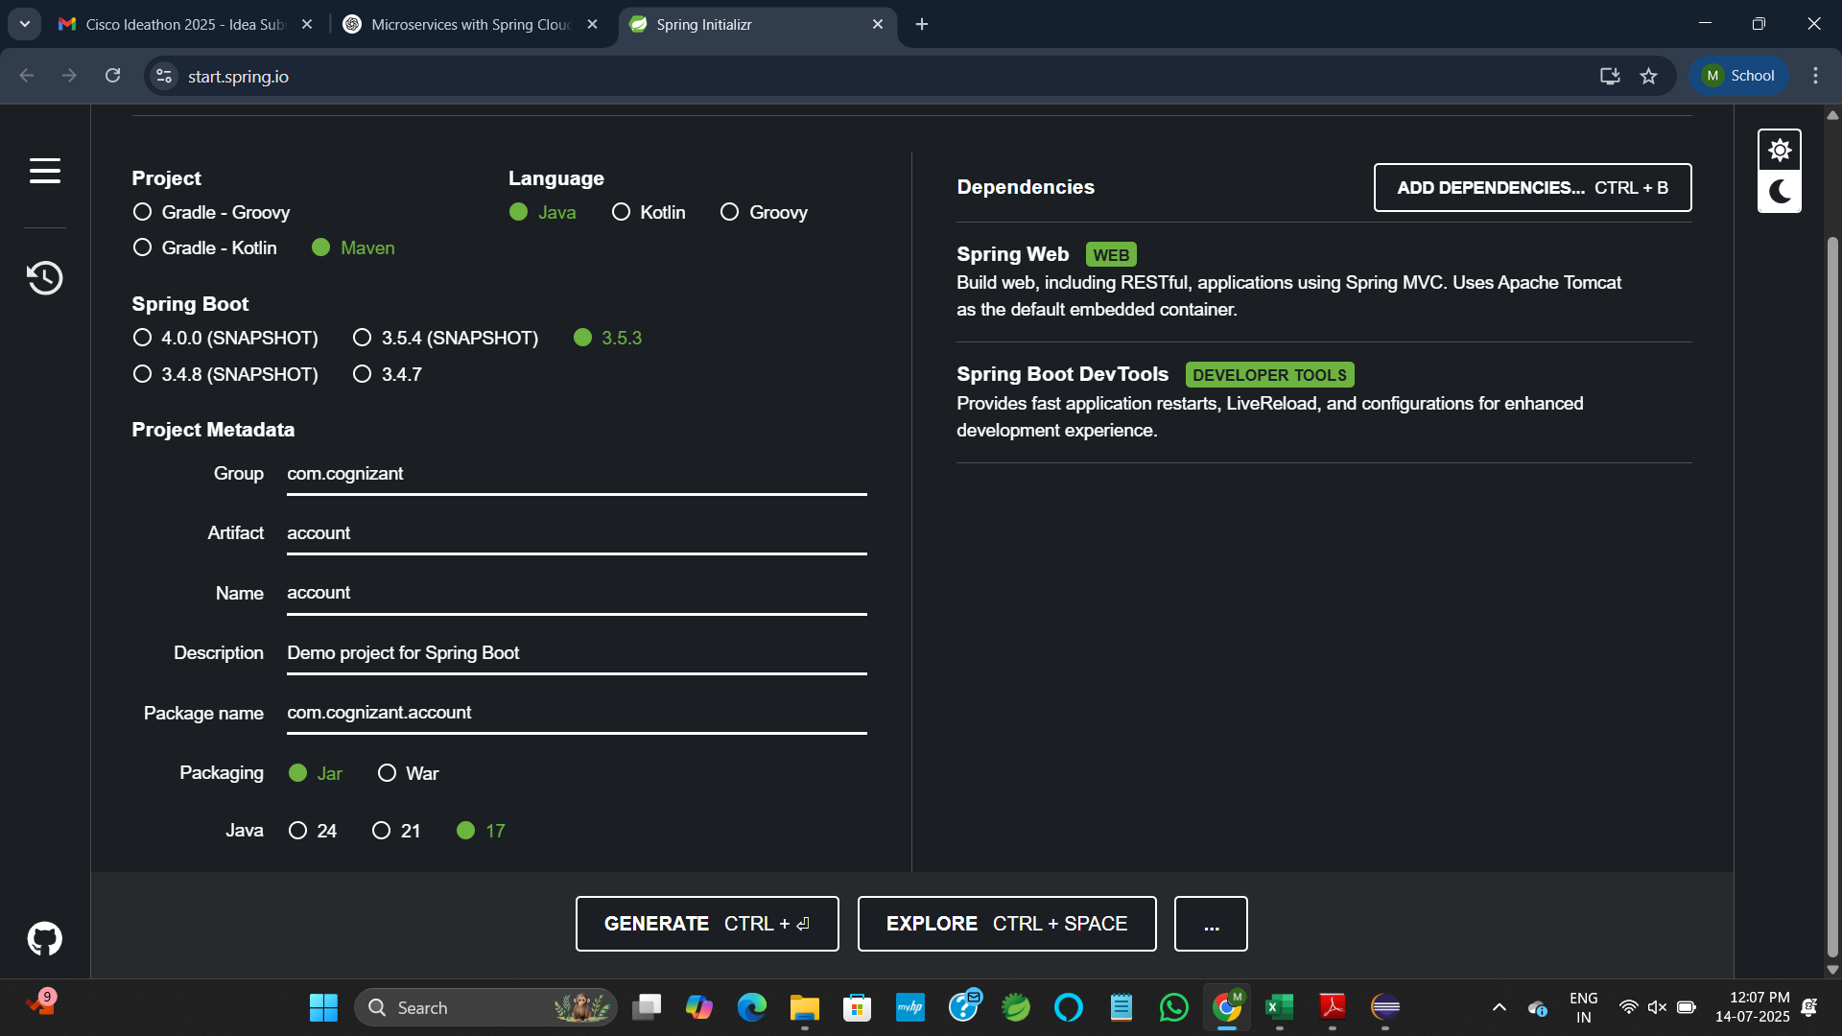

**Step 2:** Unzip & Move Project

* Unzip the downloaded file.
* Move the account folder to the destinated folder.
* Open **Eclipse**.
* Go to: File > Import > Existing Maven Projects
* Finish import.

**Step 3:** Create AccountController class

**AccountController.java**

package com.cognizant.account;

import org.springframework.web.bind.annotation.*;

*@RestController*

public class AccountController {

*@GetMapping*("/accounts/{number}")

public Account getAccount(*@PathVariable* String number) {

return new Account(number, "savings", 234343);

}

static class Account {

public String number;

public String type;

public double balance;

public Account(String number, String type, double balance) {

this.number = number;

this.type = type;

this.balance = balance;

}

}

}

**applications.properties**spring.application.name=loan

server.port=5673

logging.level.root=DEBUG

**OUTPUT:**

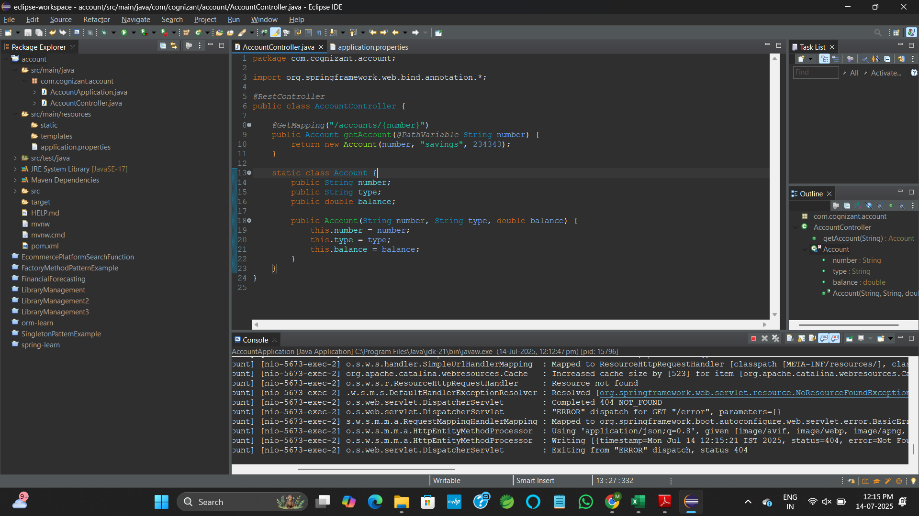

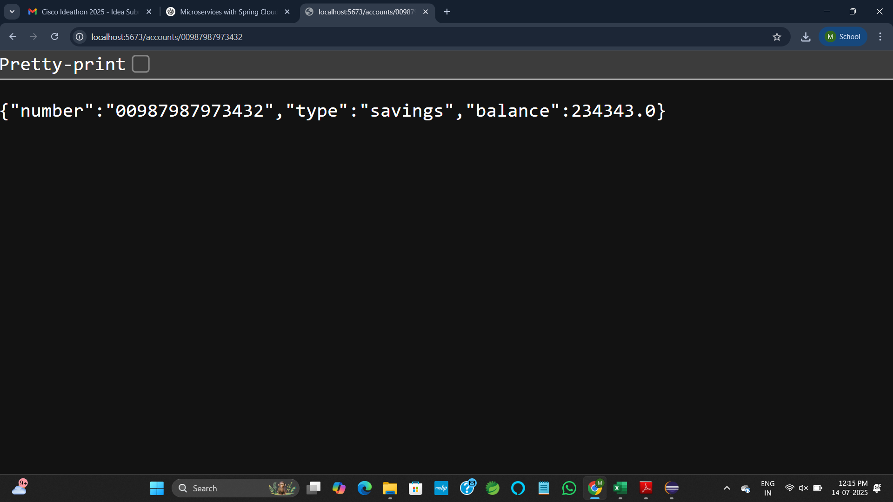

**Part 2: Create Loan Microservice**

**Step 1:** Use Spring Initializer

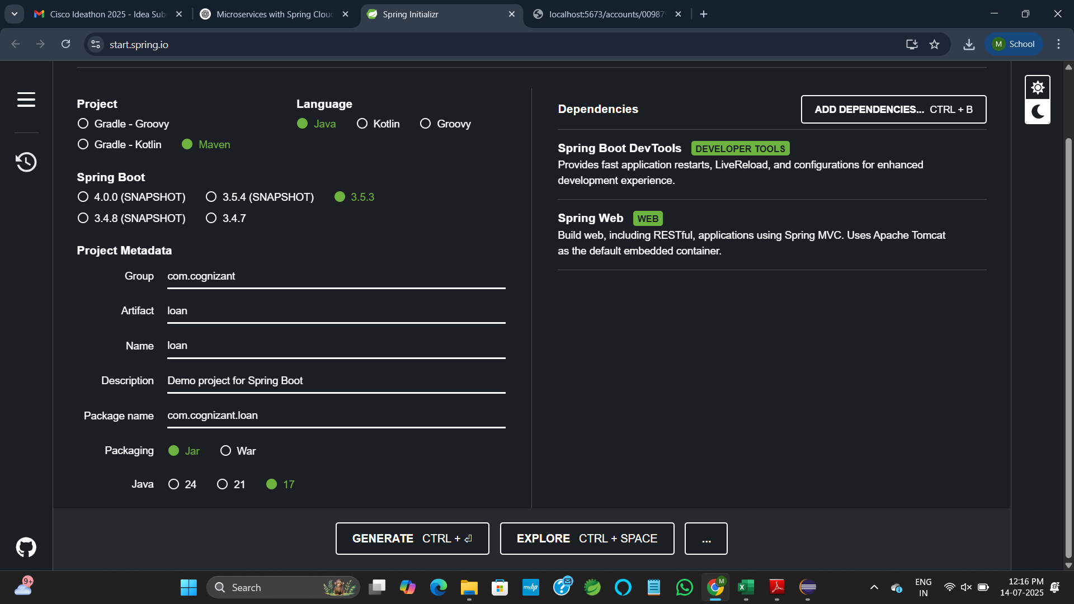

**Step 2:** Unzip & Move Project

* Unzip the downloaded file.
* Move the loan folder to the destinated folder.
* Open **Eclipse**.
* Go to: File > Import > Existing Maven Projects
* Finish import.

**Step 3:** Create LoanController class

**LoanController.java**

package com.cognizant.loan;

import org.springframework.web.bind.annotation.*;

*@RestController*

public class LoanController {

*@GetMapping*("/loans/{number}")

public Loan getLoan(*@PathVariable* String number) {

return new Loan(number, "car", 400000, 3258, 18);

}

static class Loan {

public String number;

public String type;

public double loan;

public double emi;

public int tenure;

public Loan(String number, String type, double loan, double emi, int tenure) {

this.number = number;

this.type = type;

this.loan = loan;

this.emi = emi;

this.tenure = tenure;

}

}

}

**applications.properties**spring.application.name=loan

server.port=

logging.level.root=DEBUG

**OUTPUT:**

